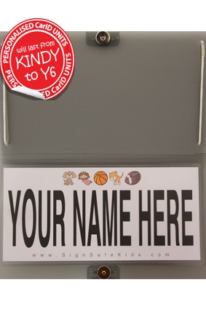

To help our afternoon pick up queue move safely and efficiently, please go to signsafekids.com to order a
CarID for only $18.95 (+P&H).

The plastic unit will attach to your passenger side sun visor and display your family name clearly to our duty staff.

Your unit will last from Kindy to Year 6, so is a worthwhile investment for all families that utilize our school carline.

